Supplemental material

Table S1. Delphi consensus on responses generated by three large language models to renal cell carcinoma management questions. 2
Figure S1. Proportion of panelists scoring in each category (1–3 = disagreement, 4–6 = no consensus, 7–9 = agreement) per clinical question and large language model after both Delphi rounds. 6

Table S1. Delphi consensus on responses generated by three large language models to renal cell carcinoma management questions.
Guideline-based questions | Delphi results by LLM^{1,2} |  |  | Summary of main panelists’ comments | Panelists  (n)
Guideline-based questions | Claude | Gemini | ChatGPT | Summary of main panelists’ comments | Panelists  (n)
1.In a patient with metastatic disease, is cytoreductive nephrectomy recommended after immunotherapy treatment? | 1st round (85.7%) | 2nd round (75.0%) | 1st round (71.4%) | - ChatGPT: Responds incorrectly that CARMENA and SURTIME are immunotherapy trials, when in fact they studied tyrosine kinase inhibitors. | 7
2. In the context of adjuvant treatment following metastasectomy, can any immune checkpoint inhibitor be used? | 2nd round (83.3%) | 2nd round (83.3%) | 1st round (83.3%) | - Gemini: Incorrectly attributes M1 NED outcomes to trials that did not include this subgroup | 6
3. Do mTOR pathway inhibitors have a role in the treatment of metastatic renal cell carcinoma? | 2nd round (83.3%) | 1st round (100%) | 1st round (83.3%) |  | 6
4. In which patients with metastatic renal cell carcinoma (RCC) is active surveillance (without immediate systemic treatment) a reasonable initial strategy, and what are the selection criteria based on current evidence? | 1st round (100%) | No consensus (66.7%) | 1st round (83.3%) | - ChatGPT: Incorrectly claims that CARMENA and SURTIME support delaying systemic therapy, but neither trial evaluated this strategy | 6
5. What are the current indications for metastasectomy in metastatic RCC? | 1st round (85.7%) | 2nd round (85.7%) | 1st round (100%) |  | 7
6. In the case of recurrence after adjuvant pembrolizumab, what is the most appropriate treatment and what factors should be considered? | 1st round (83.3%) | 2nd round (83.3%) | 2nd round (100%) | - Gemini: Fails to address the question posed. | 6
7. What are the local therapeutic alternatives in patients with oligometastatic disease? | 1st round (77.8%) | 2nd round (88.9%) | 1st round (88.9%) | - Claude: Mentions a risk model (MSKCC) that is no longer in current use. | 9
8. How many targeted therapies are approved for the treatment of patients with locally advanced or metastatic disease, and what are the necessary conditions for their use? | 2nd round (71.4%) | 1st round (71.4%) | 1st round (85.7%) |  | 7
9. What is the role of cytoreductive surgery in advanced renal cancer? | 1st round (75%) | 2nd round (100%) | 1st round (75%) |  | 8
10. What is the incidence of recurrence, metastasis, and survival in chromophobe renal cell carcinoma? | 1st round (85.7%) | 2nd round (71.4%) | No consensus (71.4%) |  | 7
11. What is the surgical approach in patients with different hereditary renal carcinoma syndromes? | 1st round (85.7%) | 1st round (100%) | 1st round (71.4%) |  | 7
12. Types of angiomyolipoma treatment. | 1st round (87.5%) | 1st round (100%) | 1st round (100%) |  | 8
13. Clinical Case: A 59-year-old patient with a solitary kidney, presenting with a 2 cm solid external cortical nodule compatible with renal neoplasm, diagnosed by ultrasound examination by gastroenterology. Relevant history includes a right subcostal incision for a benign nephrectomy several years ago and a midline laparotomy for perforated appendicitis during childhood. Control laboratory tests show a GFR of 50 mL/min.  What therapeutic approach would you offer this patient? | 1st round (75.0%) | 1st round (100%) | 1st round (75.0%) |  | 8
14. Would you offer adjuvant pembrolizumab treatment to a patient who underwent radical nephrectomy (for a grade IV pT4 N1 clear cell carcinoma) who is disease-free after surgery? | 1st round (100%) | 1st round (100%) | 1st round (100%) |  | 6
15. For a young patient with intermediate-risk renal cancer according to the IMDC classification and cerebral metastatic progression with two lesions during immunotherapy, which treatment would you choose between whole brain radiotherapy and stereotactic radiotherapy? | 1st round (71.4%) | 1st round (85.7%) | 1st round (85.7%) |  | 7
16. When should adrenalectomy be performed in a patient with renal cancer? | 1st round (100%) | 2nd round (87.5%) | 1st round (100%) |  | 8
17. Which ablative technique has the strongest evidence for the treatment of localized renal cancer? | No consensus (66.7%) | 1st round (85.7%) | No consensus (50%) |  | 6
18. How long should we follow up a patient with low-risk kidney cancer (Leibovich score) treated with nephrectomy? | 1st round (100%) | 1st round (100%) | 1st round (100%) | - Gemini and ChatGPT: Suggest chest CT, which is not recommended for pT1a tumors. | 7
19. Is there any alternative to renal biopsy for the differential diagnosis of small renal masses? | No consensus (87.5%) | 2nd round (75.0%) | 1st round (100%) | - Claude: Omits sestamibi SPECT/CT as a noninvasive alternative for small renal masses  - ChatGPT: The response would have been complete with mention of Zr-Girentuximab PET/CT (ZIRCON trial) | 8
20. List the therapeutic options for a 3-centimeter renal mass. | 2nd round (87.5%) | 2nd round (75.0%) | 1st round (87.5%) | - Claude and Gemini Include redundant options. | 8
21. Are there significant differences in functional outcomes and survival between laparoscopic partial nephrectomy and robot-assisted partial nephrectomy? | 1st round (100%) | 1st round (85.7%) | 1st round (100%) |  | 7
22. What is the prevalence of malignancy in Bosniak II and Bosniak IV cysts? | 1st round (100%) | 1st round (87.5%) | 1st round (100%) |  | 8
23. What is the recommended treatment for biopsy-confirmed oncocytomas? | 1st round (71.4%) | 1st round (100%) | 1st round (100%) | - Claude: Incorrectly states that biopsy is mandatory before surgery. | 7
24. Which of the two treatments is recommended for cT1a tumors, surgery or ablation? | 1st round (83.3%) | 1st round (100%) | 1st round (100%) |  | 6
25. What recommendations would you make for a young 41-year-old patient with suspected renal cancer and hereditary syndrome regarding diagnosis and treatment? | 1st round (75.0%) | 1st round (100%) | 1st round (87.5%) |  | 8
Abbreviations: CT: Computed Tomography; GFR, Glomerular Filtration Rate; IMDC, International Metastatic Renal Cell Carcinoma Database Consortium; LLM, Large Language Model; MSKCC, Memorial Sloan Kettering Cancer Center; NED, No Evidence of Disease; PET, Positron Emission Tomography; RCC, Renal Cell Carcinoma; SPECT, Single Photon Emission Computed Tomography.

¹ 1st round’ or ‘2nd round’ indicates consensus was reached in agreement in the first or second Delphi round, respectively.
² The percentage in parentheses indicates the proportion of panelists whose scores fell within the same tercile as the median of responses (1–3 = disagreement, 4–6 = no consensus, 7–9 = agreement).

Color code for consensus levels:
- Dark green: Consensus in agreement reached in the first round.
- Light green: Consensus in agreement reached in the second round.
- Yellow: No consensus reached.

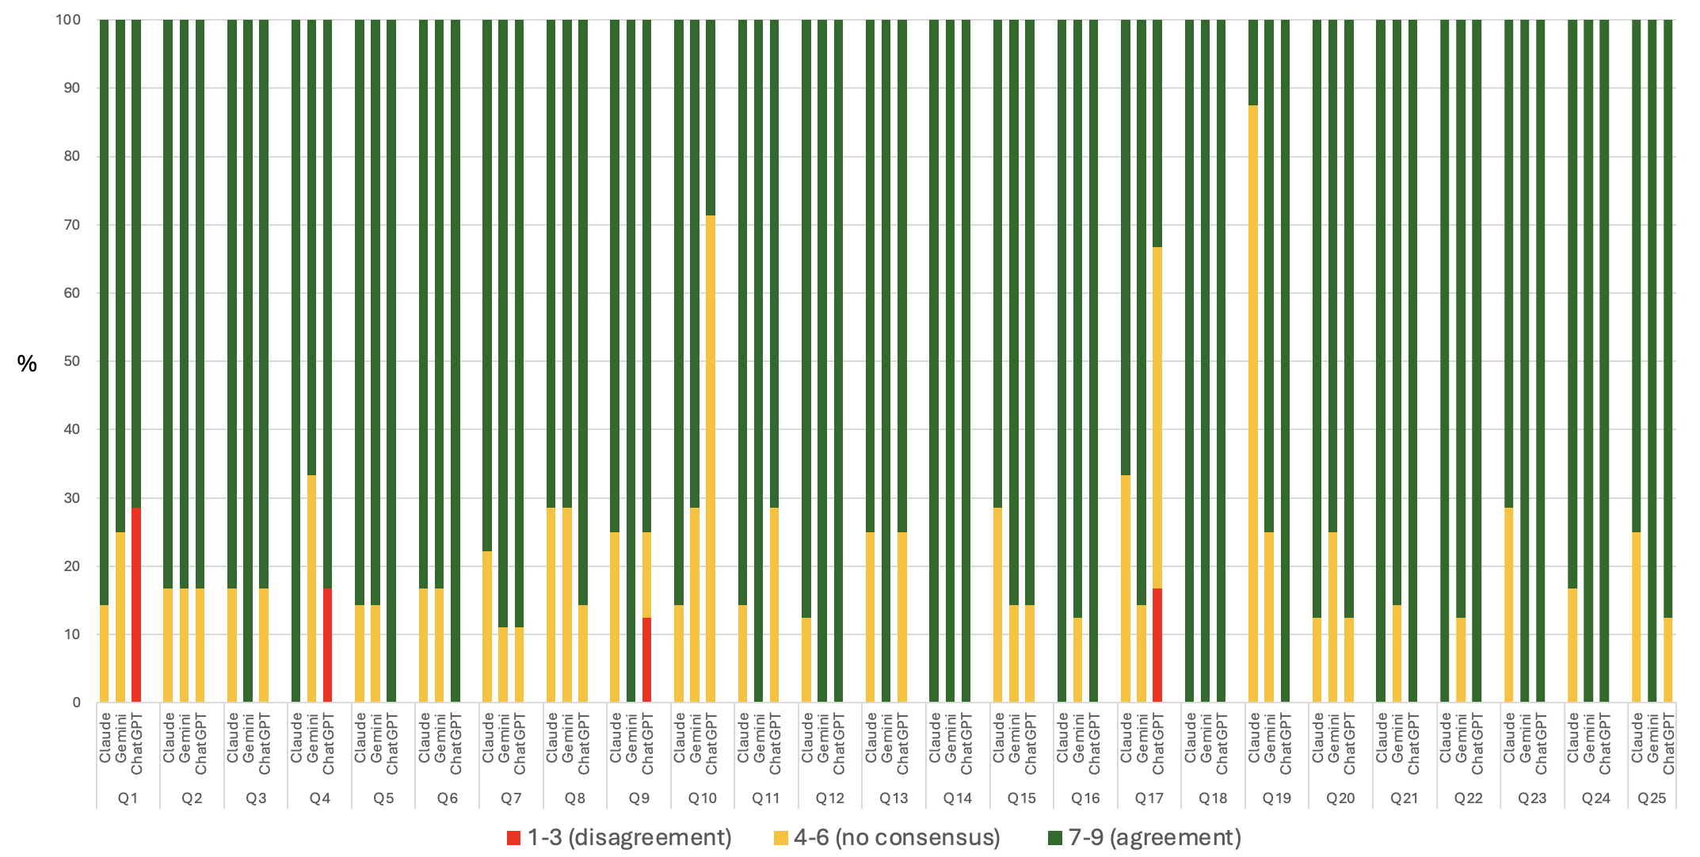
Figure S1. Proportion of panelists scoring in each category (1–3 = disagreement, 4–6 = no consensus, 7–9 = agreement) per clinical question and large language model after both Delphi rounds.

